0Appendix 8

Mandatory Disclosure

Mandatory Disclosure updated on 15 th December.2010

1. AICTE File No.:

F ms-108/B-111/RC (BB)/92 dated on 12th Jan 1994.

Date & Period of last approval :

Western Region, Maharashtra/1-10011321/2010/EOA dated 23- August 2010
Corrigendum dated 8-11-2010. Academic year 2010-11.

2. Name of the Institution:

Vidyavardhini’s College of Engineering & Technology.
Affiliated to University of Mumbai.

Address of the Institution:

K.T.Marg, Vasai Road (W.), Dist- Thane, Maharashtra.

Location map
of the Institution
City & Pin Code:

Vasai Road 401202.

State / UT:

Maharashtra.

Longitude & Latitude:

19° 21' 0'' North / 72° 48' 0'' East

Phone number with STD code:

0250-2338234/2350989

FAX number with STD code:

0250-2339486

Office hours at the Institution:

Monday – Friday 09 am to 05 pm

Academic hours at the Institution:

09 am to 05pm

Email :

vcet_inbox@vcet.edu.in

Website :

www.vcet.edu.in

Nearest Railway Station (dist in Km):

Vasai Road (W.Rly) 0.5Km

Nearest Airport (dist in Km):

Sahara Airport 50.00 Km

3. Type of Institution:

Private-Self Financed
Category (1) of the Institution:
Non Minority
Category (2) of the Institution: -
N/A.

4. Name of the organization running the Institution :

Vidyavardhini

Type of the organization:

Trust
Address of the organization:

Annasaheb Vartak College of Arts Bldg.1st floor, Vasai Road (W.), Dist.-Thane, 401 202.

Registered with:

Public Trust Registered Maharashtra office, Nasik, Bombay Public Trust Act 1950(Bom XXIV 1950)

Registration date:

26 July 1971

Website of the organization:

www.vcet.edu.in

5. Name of the affiliating University:

University of Mumbai,
Mahatma Gandhi Road,
Fort, Mumbai 400 032

Website:

mu.ac.in

Latest affiliation period:

2009-10

6. Name of Principal / Director:

Dr. Mohan N. Bhawe.

Exact Designation:

Principal,

Phone number with STD code:

(0) 0250-2350989/2350988 (R) - 022 26116009

Fax No. :

0250-2339486

Email:

principal@vcet.edu.in

Highest Degree:

Ph.D

Field of specialization:

Chemical Engineering.

7. Governing Board Members

Sr.  No. | Name of the Member | Category | Designation
1 | Shri. Pratapbhai Khokhani, | Trustee | President,
2 | Shri. Arun G. Vartak | Trustee | Chairman
3 | Shri. Uddhav J.Gharat,. | Secretary | Member
4 | Shri. Subhash Dandekar,. | Industrialist | Member
5 | Shri. M.N.alias Bhausaheb Mohol.. | Industrialist | Member
6 | Shri. Babansheth Naik, | Educationalist | Member
7 | Dr. S.K.Mahajan, | I/C Director, DTE. | Member
8 | Shri. R.M. Badode | Vice-Chancellor Nominee | Member
9 | Dr. M.N.Bhawe, | Principal | Member-Secretary

Frequency of meetings:
One meetings per year & for urgent matter special Meeting
Date of last meeting:
15th January, 2009

8. Academic Advisory Body

Sr.  No. | Name of the Member | Category | Designation
 | Dr. M.N.Bhawe, | Principal | Chairman
 | Prof . Vikas Gupta | H.O.D EXTC | Member
 | Prof. Deepak Gawali | H.O.D INST | Member
 | Prof. (Mrs) Dipti Patil | H.O.D COMP | Member
 | Prof Chandan Kolvankar | H.O.D INFT | Member
 | Prof. (Mrs) Pranali Sapre | H.O.D ASH | Member
 | Shri. Baban Mhatre | Registrar | Member

Frequency of meetings & date of:
Every Monday
Last meeting:
19th July, 2010 & 26th July, 2010

9. Organisational Chart:

Organizational chart and processes:-

Vidyavardhini Trust
Governing Council
Other Functional Heads

Dean Student Activities (Proposed)

All HOD’s
Local Managing Committee
Dean Academic
(proposed)
Registrar
Principal

10. Student feedback mechanism on Institutional Governance/faculty performance:

Every Semester, the Students present their feed back by filling up a feed back form designed by the college. These responses are compiled and the compiled results are presented to individual faculty member.

11. Grievance redressal mechanism for faculty, staff and students:

The Academic Counsel Function as Grievance Committee for faculty and Staff. Grievances of Students are attended to through direct meeting with Faculty Concerned / HOD / Principal as applicable.

12. Name of the Department*:

Course, Level UG / PG, 1st Year of approval by the Council,
Year wise Sanctioned Intake CAY CAY-1 CAY-2 :

IX.1 Number of seats sanctioned with the year of approval:-

Sr.  No. | Courses | Year of  Approval | Sanctioned  intake  CAY  2010-11 | Sanctioned  intake  CAY-1  2009-10 | Sanctioned  intake  CAY-2  2008-09
 | UNDER-GRADUATE
1 | Electronics and Telecommunication Engineering.( EXTC) | 1994 | 60 | 60 | 60
2 | Instrumentation Engineering.  (INST) | 1994 | 60 | 60 | 60
3 | Mechanical Engineering. (MECH) | 1994 | 60 | 60 | 60
4 | Computer Engineering.  ( COMP) | 2000 | 60 | 60 | 60
5 | Information Technology.(INFT) | 2000 | 60 | 60 | 60

Year wise Actual Admissions CAY CAY-1 CAY-2
Provide details of number of seats, cut-off percentage
Number of seats:-
300
Duration:-
4 Years

UG PROGRAMS ( 4Year's Duration) | Intake | Actual Adm. | 2010-11 |  | Actual Adm | 2009-10 |  | Actual Adm | 2008-09
UG PROGRAMS ( 4Year's Duration) | Intake | Actual Adm. | Cut-off % CET Score |  | Actual Adm | Cut-off % CET Score |  | Actual Adm | Cut-off % CET Score
UG PROGRAMS ( 4Year's Duration) | Intake | Actual Adm. | OC | RC | Actual Adm | OC | RC | Actual Adm | OC | RC
Electronica and telecommunication Engineering. ( EXTC ) | 60 | 61 | 171 | 62 | 62 | 140 | 51 | 62 | 126 | 50
Instrumentation Engineering. ( INST ) | 60 | 60 | 140 | 56 | 61 | 115 | 39 | 60 | 118 | 18
Mechanical Engineering ( MECH ) | 60 | 61 | 182 | 55 | 61 | 122 | 58 | 60 | 97 | 62
Computer Engineering. ( COMP ) | 60 | 60 | 177 | 59 | 61 | 122 | 49 | 61 | 146 | 56
Information Techonology ( INFT ) | 60 | 59 | 144 | 43 | 61 | 121 | 51 | 61 | 111 | 64
OC- Open candidate RC- Reserved candidate
% Students passed with Distinction CAY CAY-1 CAY-2
% Students passed with First Class CAY CAY-1 CAY-2

S.No. | Course | Year | Sanctioned Intake / Student Appeared | Students Passed out in first attempt | % of  Students  passed in  first  attempt | % of  Students  passing out  with  Distinction | % of  Students  with 1st  Division
1 | Electronics and Telecommunication Engineering.  ( EXTC) | May 08 | 60 / 66 | 65 | 98 | 28 | 54
1 | Electronics and Telecommunication Engineering.  ( EXTC) | May 09 | 60 / 76 | 70 | 92 | 10 | 59
1 | Electronics and Telecommunication Engineering.  ( EXTC) | May 10 | 60/71 | 67 | 94 | 8 | 36
2 | Instrumentation Engineering.  (INST) | May 08 | 60 / 59 | 59 | 100 | 22 | 54
2 | Instrumentation Engineering.  (INST) | May 09 | 60 / 63 | 58 | 92 | 22 | 55
2 | Instrumentation Engineering.  (INST) | May 10 | 60/69 | 67 | 97 | 20 | 28
3 | Mechanical Engineering. (MECH) | May 08 | 60 / 64 | 63 | 98 | 39 | 45
3 | Mechanical Engineering. (MECH) | May 09 | 60 / 75 | 54 | 72 | 16 | 45
3 | Mechanical Engineering. (MECH) | May 10 | 60/74 | 67 | 90 | 13 | 41
4 | Computer Engineering.  ( COMP) | May 08 | 60 / 62 | 59 | 95 | 17 | 56
4 | Computer Engineering.  ( COMP) | May 09 | 60 / 67 | 65 | 97 | 25 | 59
4 | Computer Engineering.  ( COMP) | May 10 | 60/72 | 100 | 72 | 20 | 38
5 | Information Technology.(INFT) | May 08 | 60 / 74 | 70 | 94 | 06 | 48
5 | Information Technology.(INFT) | May 09 | 60 / 73 | 71 | 97 | 31 | 50
5 | Information Technology.(INFT) | May 10 | 60/69 | 48 | 92 | 15 | 38

Students Placed CAY CAY-1 CAY-2

Sr.  No. | Discipline | Total no. of students placed through  placement cell  (last 3 years)
 |  | 2010-11 | 2009-10 | 2008-09 | 2007 - 08
1 | Electronics and Telecommunication Engineering.  ( EXTC) | 26 | 26 | 40 | 47
2 | Instrumentation Engineering.  (INST) | 25 | 23 | 33 | 23
3 | Mechanical Engineering. (MECH) | 45 | 44 | 19 | 34
4 | Computer Engineering.  ( COMP) | 30 | 30 | 34 | 33
5 | Information Technology.(INFT) | 17 | 17 | 29 | 32

Average Pay package, Rs./Year CAY CAY-1 CAY-2 :

Sr.  No. | Particulars of  Salaries Per  Annum | 2010-2011  (Rs.In Lakhs) | 2009– 2010  (Rs. In Lakhs) | 2008 – 2009  (Rs. In Lakhs) | 2007 – 2008  (Rs. In Lakhs)
1 | Minimum Salary | 1.80 | 1.80 | 1.44 | 1.66
2 | Maximum Salary | 3.50 | 4.50 | 3.25 | 2.98
3 | Average Salary | 2.65 | 3.15 | 2.34 | 2.32

Students opted for Higher Studies CAY CAY-1 CAY-2

Students opted  for Higher Studies | 2009 – 10 | 2008 – 2009 | 2007-08
Students opted  for Higher Studies | 92 | 55 | 45

Accreditation Status of the course :

Application was made on 20th Dec 2009

Doctoral Courses :

No

Foreign Collaborations, if any :
No

Professional Society Memberships :

IEEE, SAE. ASME. ACM, ISA, ISTE,

Professional activities :

Every year, a joint technical festival “ORION” is organized wherein the students show case their technical process through paper presentations, quizzes, games etc. Being an “inter collegiate” Techfest, there is a sizeable presence and participation of students from other Engineering colleges afflicted to the University.

An addition, each student chapter organizes talks, seminars wherein eminent professionals are invited for talks on their subjects of interest. Such occasions also allow the students to interact with such persons.

Consultancy activities:

Grants fetched:

Departmental Achievements:

Distinguished Alumni:

13. Name of Teaching Staff* 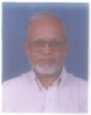

PROFILE OF DIRECTOR/PRINCIPAL

- Name: Dr. Mohan N. Bhawe.

- Date of Birth: 10th July, 1947.

- Educational Qualification: B.Chem.Engg. M.S,
Ph.D.(Chemical Engg.).

- Work Experience:- 39 Years

Designation: Principal

University Approval letter No. :
Concol/SA/2439 of 2010 dated 2010 with effect from 22/08/2005

- Teaching : 10 Years
- Industry : 29 Years
- Research : -
- Other :__________

- Area of Specializations: Chemical Engineering.

- Subjects taught at Under Graduate Level: 1. Chemical Processes I & II.
2. Environmental Engineering.
3. Chemical Reaction Engg.
4. Plant Safety
.
Post Graduate Level:

7 Research guidance: ------------

No. of papers published in
Masters’s - National Journals -
Ph.D. - International Journals -
- Conferences
- Projects Carried out : 1. Splitting of fats using Castor bean based Lipase
2. Adsorption of Arsenic in drinking water using Iron oxide
Complexes .
3. Application of Neem Oil emulsions for bio-disinfection of
Irrigation water.
9 Patents

10 Technology Transfer : Several plants built based on proprietary technology for
manufacturing chemicals.

11 Research Publications -

12 No. of Books published with details -

13 International Conference attended_________________

LIST OF STAFF MEMBERS ALONGWITH PHOTOGRAPHS

Electronics & Telecommunication Engg. (UG)

Sr.No. | Name of the Staff | Designation | Photo
1 | Prof. Gupta Vikas | Associate. Professor. & HOD | 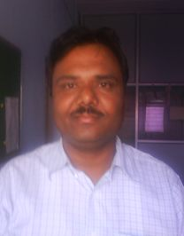
2 | Prof. Ruperee Amruta | Assistant. Professor. | 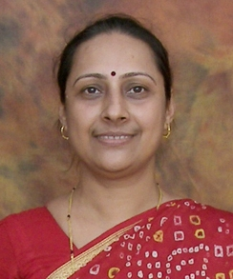
3 | Prof.Patil Sunayana | Assistant. Professor. | 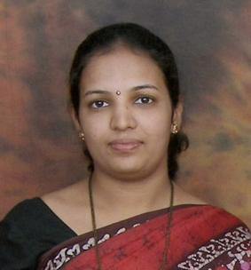
4 | Prof.Vanmali Ashish | Assistant. Professor. | 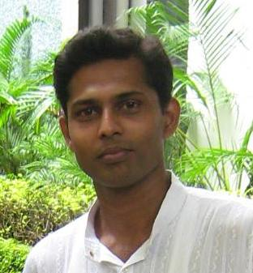
5 | Mr. Dhar Sunitikumar | T.P.O.-Assistant Professor. | 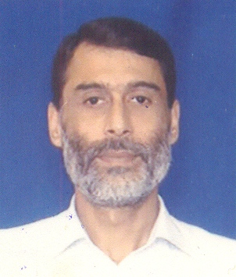
6 | Ms. Khan Shaista | Assistant. Professor. | 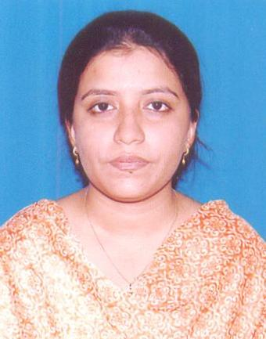
7 | Ms. Gosavi Sharadha | Assistant. Professor. | 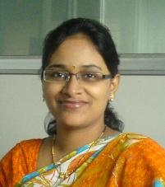
8 | Ms. Supalkar Sandhya | Assistant. Professor. | 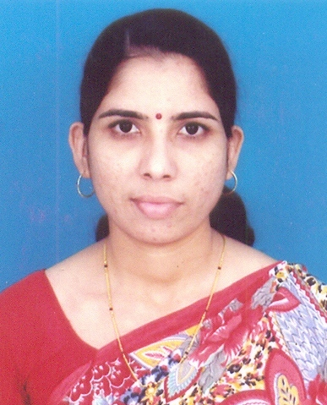
9 | Ms.Katkar Ashwini | Assistant. Professor. | 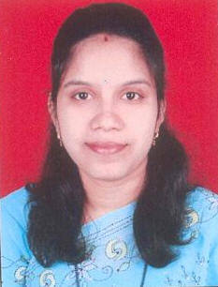
10 | Ms .GharatNeha | Assistant. Professor. | 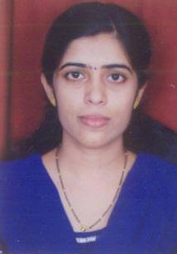
11 | Ms.Naik Ekta | Assistant. Professor. | 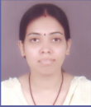
12 | Ms. Shah Trupti | Assistant. Professor. | 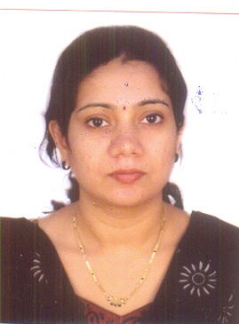
13 | Mr. Pawar Sandeep | Assistant. Professor. | 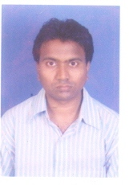
14 | Ms. Kamat Dipti | Lecturer | 
15 | Mr. Manoj Kamble | Lecturer | 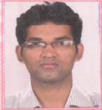

Instrumentation Engg. (UG)

Sr.No. | Name of the Staff | Designation | Photo
1 | Prof. Gawali Deepak | Associate. Professor. & HOD | 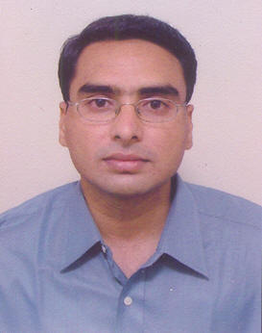
2 | Prof. Patlekar Kanchan | Assistant.Professor. | 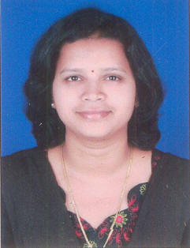
3 | Prof. Trivedi Megha | Assistant Professor. | 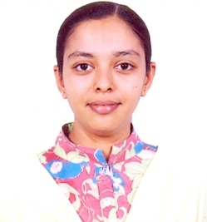
4 | Mrs. Bhuran Supriya | Assistant Professor | 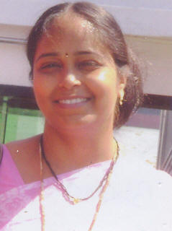
5 | Mrs. Salvi Mugdha | Assistant Professor | 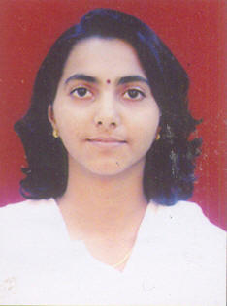

6 | Mr. Patil Prafulla | Assistant Professor | 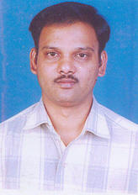
7 | Mr. Pande Vishal | Assistant Professor | 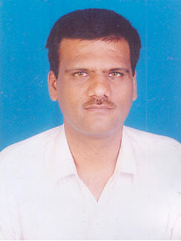
8 | Ms. Mahadeshwar Dipti | Assistant Professor | 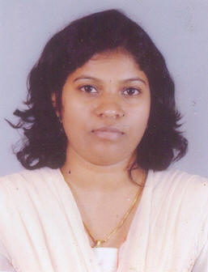
9 | Ms. Mane Trupti | Assistant Professor | 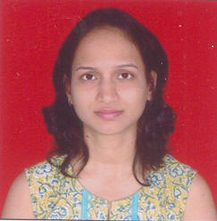
10 | Ms. Patil Vidya | Assistant Professor | 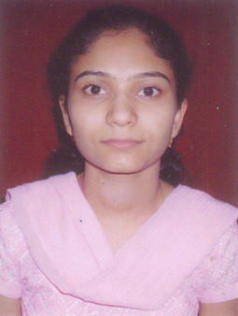

11 | Mr. Hangal Swaroop | Assistant Professor | 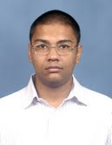
12 | Mrs. Vartak Vinita | Lecturer | 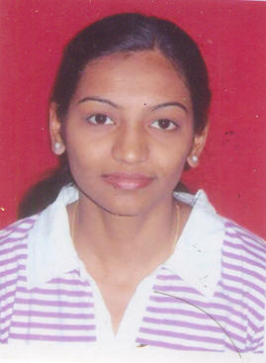
13 | Ms. Uchil Bishal | Lecturer | 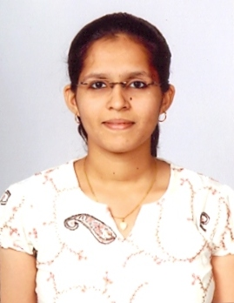

Mechanical Engg. (UG)

Sr.No. | Name of the Staff | Designation
1 | Prof.Aswalekar Uday | Associate Professor & HOD | 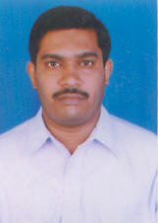
2 | Prof.Jilte Ravindra | Assistant Professor | 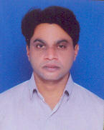
3 | Mr. Lopes Sylvester | Assistant Professor | 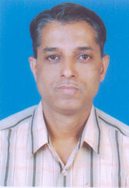
4 | Mr. Dhale Ashok | Assistant Professor | 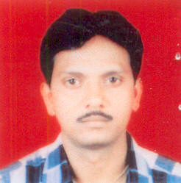
5 | Mr. Chaudhari Deepak | Assistant Professor | 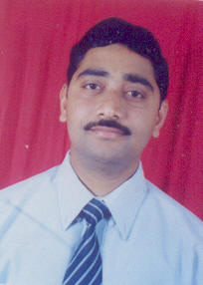
6 | Mr. Patel Vinay | Assistant Professor | 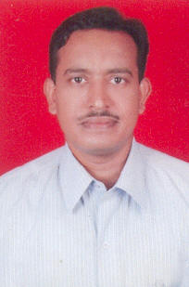
7 | Mr. Chaudhari Ashish. | Assistant Professor | 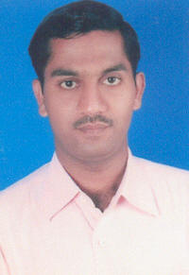
8 | Ms. Dutta Madhumita | Assistant Professor | 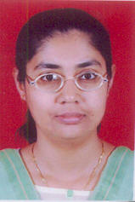
9 | Mr. Mane Swapnil | Assistant Professor | 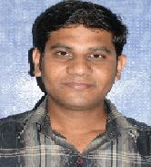
10 | Mr. Sanjay Lohar | Assistant Professor
11 | Mr. Garud Prakash | Lecturer | 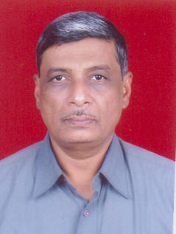
12 | Mr. Ashutosh Hawaldar | Lecturer
13 | Mr. Siddharth Rao | Lecturer
14 | Mr. Amit Chaudhari | Lecturer
15 | Mr. Ashwani Sharma | Lecturer

Computer Engg. (UG)

Sr.No. | Name of the Staff | Designation | Photo
1 | Prof.Swapna Borde | Associate Professor & HOD | 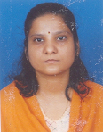
2 | Mr. Agaskar Vikrant | Assistant Professor | 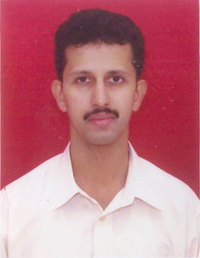
3 | Mr. Hingmire Anil | Assistant Professor | 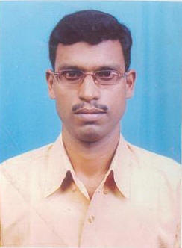
4 | Mrs. Chaudhari Sangeeta | Assistant Professor | 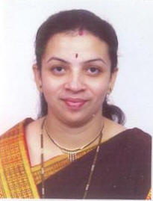
5 | Ms. Jawale Smita | Assistant Professor | 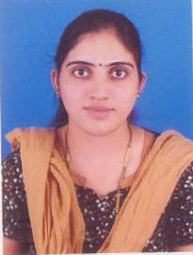
6 | Mr. Lakhe Pravin | Assistant Professor | 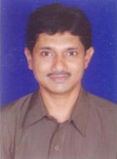
7 | Mr. Katkar Sunil | Assistant Professor | 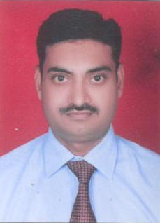
8 | Ms. Rupani Sweety | Assistant Professor | 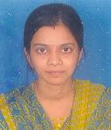
9 | Mr. Hirani Imtiyaz | Assistant Professor | 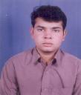
10 | Mr. Chandorkar Bharat | Lecturer | 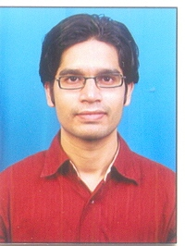
11 | Ms. Ankita Mhatre | Lecturer | 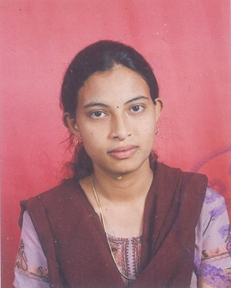
12 | Mr. Tatvadarshi Nagarhali | Lecturer | 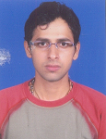
13 | Mrs. Baviskar Priti | Lecturer
14 | Ms. Badhe Bahrti | Lecturer | 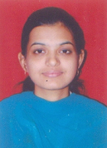
15 | Mrs. Patil Pooja | Lecturer | 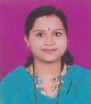

Information Technology (UG)

Sr.No. | Name of the Staff | Designation | Photo
1 | Prof.Kolvankar Chandan | Assistant Professor &  HOD | 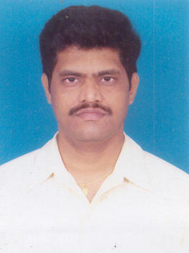
2 | Prof Ekbote Archana | Assistant. Professor | 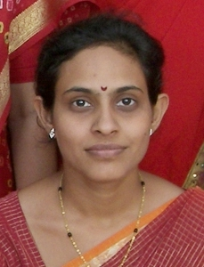
3 | Prof. Gangurde Madhavi | Assistant. Professor | 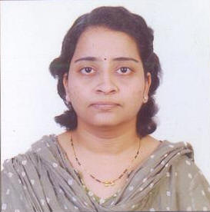
4 | Ms. Shirsat Vaishali | Assistant. Professor | 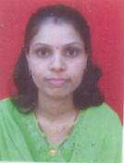
5 | Ms. Wankhede Anokhi | Assistant. Professor | 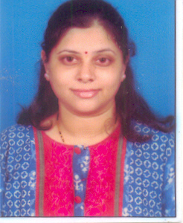

6 | Mr. Patil Sainath | Assistant. Professor | 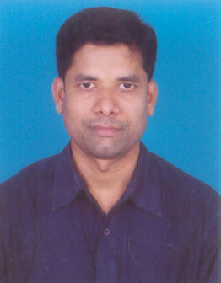
7 | Ms. Patil Anagha | Assistant. Professor | 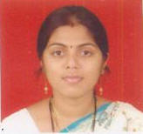
8 | Ms. Gondhlekar Bharati | Assistant. Professor | 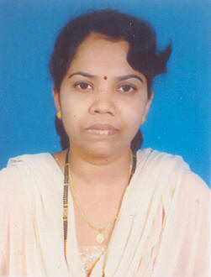
9 | Mr. Pingle Yogesh | Assistant. Professor | 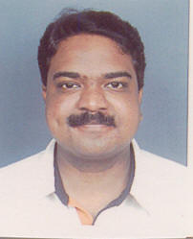
10 | Ms. Jawadwala Mariyam | Assistant. Professor | 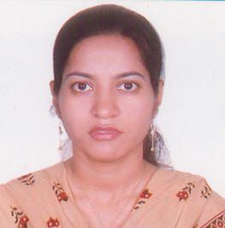
11 | Ms. Coelho Sharon | Assistant. Professor | 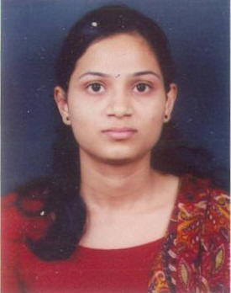

12 | Ms. Saigaonkar Swati | Assistant. Professor | 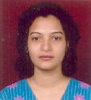
13 | Ms. Machado Speril | Lecturer | 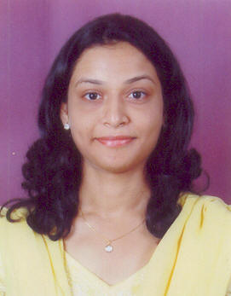
14 | Mr.Mehul Khanderia | Lecturer | 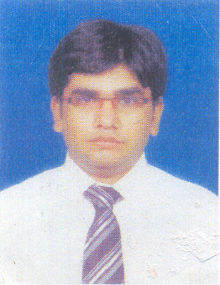

Applied Sciences & Humanities (UG)

Sr.No. | Name of the Staff | Designation | Photo
1 | Ms. Sapre Pranali | Assistant Professor & HOD | 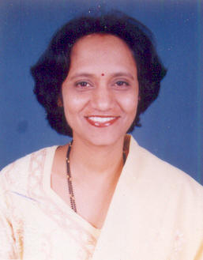
2 | Ms. Dhuri Vaishali | Assistant Professor
3 | Ms. Kamble Chandarkishori | Assistant Professor
4 | Mr. Dhas Vishwas | Assistant Professor | 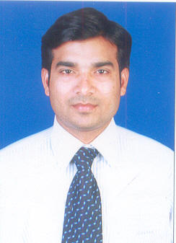
5 | Ms. Patil Mamta | Assistant Professor | 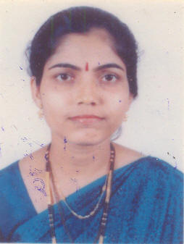
6 | Mr. Gulbhile Pradeep | Assistant Professor
7 | Mr. Patil Abhijeet | Assistant Professor
8 | Ms Pranutha Sundeep | Assistant Professor
9 | Ms. Amisha Joshi | Assistant Professor
10 | Ms. R. Kalaiarasi | Lecturer | 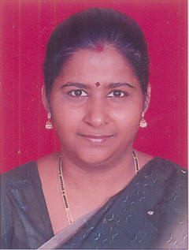
11 | Ms. Bhatacharya Mili | Lecturer
12 | Ms. Bendale Harshala | Lecturer
13 | P. Khopade | Lecturer

Information of the faculty
Sr no | Full name | Exact |  | Qualification |  |  |  |  | Date of Birth |  | Date of joining |  |  | Experience
1 | Dr. Mohan N. Bhawe. | Designation |  | UG |  | PG |  | Doctral |  |  |  |  |  | Teaching |  | Industry
1 | Dr. Mohan N. Bhawe. | Principal |  | B.E |  | MS |  | Ph.D | 10/7/1947 |  | 22/08/05 |  |  | 10 |  | 29
UG-Electronics & Telecommunication Engg.

1 | Prof. Gupta Vikas |  | Associate Professor. & HOD |  | B.E |  | M.E |  |  | 12/9/69 |  | 06/07/00 | 16Y 5M
2 | Prof. Ruperee Amruta |  | Associate Professor |  | B.E |  | M.E |  |  | 30/10/68 |  | 31/07/00 | 16Y 1M
3 | Prof.Patil Sunayana |  | Assistant Professor. |  | B.E |  | M.E |  |  | 5/9/75 |  | 07/08/01 | 9Y 11M |  | 6M
4 | Prof.Vanmali Ashish |  | Assistant Professor. |  | B.E |  | M.E |  |  | 14/1/80 |  | 12/09/03 | 8Y 3M
5 | Mr. Dhar Sunitikumar |  | T.P.O.- Assistant Professor. |  | B.E |  | - |  |  | 21/5/64 |  | 12/06/02 | 10Y |  | 16Y
6 | Ms. Khan Shaista |  | Assistant Professor |  | B.E |  | - |  |  | 26/12/81 |  | 11/07/05 | 6Y 5M
7 | Ms. Gosavi Sharadha |  | Assistant Professor |  | B.E |  | - |  |  | 7/9/82 |  | 02/01/07 | 3Y 6M
8 | Ms. Supalkar Sandhya |  | Assistant Professor |  | B.E |  | M.E |  |  | 20/6/75 |  |  | 8Y
9 | Ms.Katkar Ashwini |  | Assistant Professor |  | B.E |  | - |  |  | 2/5/81 |  | 17/07/07 | 2Y 11M
10 | Ms .GharatNeha |  | Assistant Professor |  | B.E |  | - |  |  |  |  | 16/07/07 | 2Y 11M
11 | Ms.Naik Ekta |  | Assistant Professor |  | B.E |  | M.E |  |  |  |  |  | 3Y 6M
12 | Ms. Shah Trupti |  | Assistant Professor |  | B.E |  | - |  |  |  |  | 27/07/09 | 6Y
13 | Mr. Pawar Sandeep |  | Assistant Professor |  | B.E |  | -
14 | Mr. Manoj Kamble |  | Lecturer |  | B.E |  | - |  |  |  |  | 01/02/10 | 5M
UG -Instrumentation Engg.

1 |  | Prof. Gawali Deepak |  | Associate Professor. & HOD | B. E | M. E |  |  | - |  |  | 24/1/77 |  |  | 01/01/06 |  |  | 10Y | 1Y 6M
2 |  | Prof. Patlekar Kanchan |  | Assistant Professor | B. E | M. E |  |  | - |  |  | 1/5/79 |  |  | 25/07/01 |  |  | 9Y 6M
3 |  | Prof. Trivedi Megha |  | Assistant Professor | B. E | M. E |  |  | - |  |  | 4/2/80 |  |  | 26/07/02 |  |  | 8Y
4 |  | Ms. Bhuran Supriya |  | Assistant Professor | B. E | - |  |  | - |  |  | 28/11/81 |  |  | 17/01/05 |  |  | 5Y 6M | 1Y 6M
5 |  | Ms. Salvi Mugdha |  | Assistant Professor | B. E | M. E |  |  | - |  |  | 22/1/80 |  |  | 11/07/05 |  |  | 5Y 5M | 7M
6 |  | Mr. Patil Prafull |  | Assistant Professor | B. E | M. Tech. |  |  | - |  |  | 27/9/78 |  |  | 01/01/06 |  |  | 4Y 8M | 2Y
7 |  | Mr. Pande Vishal |  | Assistant Professor | B. E | M. E |  |  | - |  |  | 19/7/76 |  |  | 11/07/05 |  |  | 11Y 5M
8 |  | Ms. Mahadeshwar Deepti |  | Assistant Professor | B. E | M. E. |  |  | - |  |  | 6/1/83 |  |  | 17/07/06 |  |  | 4Y 10M
9 |  | Ms. Mane Trupti |  | Assistant Professor | B. E | M. E |  |  | - |  |  | 14/4/83 |  |  | 01/08/07 |  |  | 5Y 10M
10 |  | Ms. Patil Vidya |  | Assistant Professor | B. E | - |  |  | - |  |  | 20/12/86 |  |  | 18/8/08 |  |  | 2Y
11 |  | Mr. Hangal Swaroop |  | Assistant Professor | B. E | - |  |  | - |  |  | 9/8/84 |  |  | 03/08/09 |  |  | 1 Y | 3Y
12 |  | Mrs. Vartak Vinita |  | Lecturer | B. E | - |  |  | - |  |  | 30/11/82 |  |  | 13/07/09 |  |  | 1Y 7M | 4Y 6M
13 |  | Ms. Uchil Bishal |  | Lecturer | B. E | - |  |  | - |  |  | 22/12/87 |  |  | 03/08/09 |  |  | 10M
UG-Mechanical Engg.

1 |  | Prof.Aswalekar Uday |  | Associate Professor. & HOD | B.E | M.E |  |  |  |  |  | 22/9/96 |  |  | 11/01/99 |  |  | 10Y 6M
2 |  | Prof.Jilte Ravindra |  | Assistant Professor | B.E | M.E |  |  |  |  |  | 4/11/93 |  |  | 11/09/01 |  |  | 8Y 11M
3 |  | Mr. Lopes Sylvester |  | Assistant Professor | B.E | - |  |  |  |  |  | 26/11/ 58 |  |  | 18/12/98 |  |  | 10Y 10M | 16Y 8M
4 |  | Mr. Dhale Ashok |  | Assistant Professor | B.E | M.E |  |  |  |  |  | 8/2/69 |  |  | 16/07/97 |  |  | 12Y 8M | 2Y
5 |  | Mr. Chaudhari Deepak |  | Assistant Professor | B.E | M.E |  |  |  |  |  | 6/11/93 |  |  | 02/08/99 |  |  | 10Y 11M
6 |  | Mr. Patel Vinay |  | Assistant Professor | B.E | M.E |  |  |  |  |  | 19/9/94 |  |  | 03/09/03 |  |  | 7Y 9M
7 |  | Mr. Chaudhari Ashish. |  | Assistant Professor | B.E | M.E |  |  |  |  |  | 26/9/98 |  |  | 11/09/03 |  |  | 7Y 10M
8 |  | Ms. Dutta Madhumita |  | Assistant Professor | B.E | - |  |  |  |  |  | 22/11/  71 |  |  | 17/01/05 |  |  | 8Y 5M | 9Y 2M
9 |  | Mr. Mane Swapnil |  | Assistant Professor | B.E | - |  |  |  |  |  |  |  |  | Jan 09 |  |  | 1Y 6M | 1Y
10 |  | Mr. Garud Prakash |  | Assistant Professor | B.E | - |  |  |  |  |  | 17/9/48 |  |  | 01/08/06 |  |  | 4Y 11M | 32Y
11 |  | Mr. Sanjay Mistry |  | Assistant Professor | B.E | - |  |  |  |  |  |  |  |  | 21/01/10 |  |  | 6M
UG -Computer Engg.

1 | Prof.Swapna Borde |  |  | Associate Professor. & HOD | B.E | M.E
2 | Mr. Agaskar Vikrant |  |  | Assistant Professor | B.E | - |  |  |  |  |  | 28/5/96 |  |  | 28/07/02 |  |  | 7Y 11M | 1Y 4M
3 | Mr. Hingmire Anil |  |  | Assistant Professor | B.E | - |  |  |  |  |  | 30/10/  96 |  |  | 11/08/03 |  |  | 9Y 2M
4 | Mrs. Chaudhari Sangeeta |  |  | Assistant Professor | B.E | M.E |  |  |  |  |  | 6/9/79 |  |  | 01/10/05 |  |  | 8Y 8M
5 | Ms. Jawale Smita |  |  | Assistant Professor | B.E | M.E |  |  |  |  |  | 30/12/  81 |  |  | 01/01/06 |  |  | 5Y 2M
6 | Mr. Lakhe Pravin |  |  | Assistant Professor | B.E | - |  |  |  |  |  | 23/3/73 |  |  | 11/07/05 |  |  | 5Y 10M | 2Y
7 | Mr. Katkar Sunil |  |  | Assistant Professor | B.E | - |  |  |  |  |  | 12/9/73 |  |  | 15/07/05 |  |  | 4Y 11M
8 | Ms. Rupani Sweety |  |  | Assistant Professor | B.E | - |  |  |  |  |  |  |  |  | 16/07/09 |  |  | 2Y 6M | 4M
9 | Mr. Hirani Imtiyaz |  |  | Assistant Professor | B.E | M.S |  |  |  |  |  |  |  |  | 03/08/09 |  |  | 11M | 4Y 6M
10 | Mr. Chandorkar Bharat |  |  | Lecturer | B.E | - |  |  |  |  |  |  |  |  | 16/07/09 |  |  | 1Y
11 | Ms. Ankita Mhatre |  |  | Lecturer | B.E
12 | Mr.Tatvadarshi Ngarhali |  |  | Lecturer | B.E
13 | Mrs. Baviskar Priti |  |  | Lecturer | B.E
14 | Ms. Badhe Bharti |  |  | Lecturer | B.E
15 | Mrs. Patil Pooja |  |  | Lecturer | B.E
UG -Information Technology

1 | Prof.Kolvankar Chandan |  |  | Associate Professor. & HOD | B.E |  | M.E |  |  |  |  | 24/3/77 |  | 20/01/03 |  |  | 7Y 8M |  | 2Y 4M
2 | Prof Ekbote Archana |  |  | Assistant Professor | B.E |  | M.E |  |  |  |  | 9/7/76 |  | 07/08/02 |  |  | 9Y 11M
3 | Ms. Gangurde Madhavi |  |  | Assistant Professor | B.E |  | M.Tech |  |  |  |  | 1/4/75 |  | 01/10/04 |  |  | 6Y |  | 3Y 6M
4 | Ms. Shirsat Vaishali |  |  | Assistant Professor | B.E |  | M.E  Pursuing |  |  |  |  | 25/7/80 |  | 06/09/04 |  |  | 5Y 10M
5 | Ms. Wankhede Anokhi |  |  | Assistant Professor | B.Tech |  | M.Tech  Pursuing |  |  |  |  | 25/10/8 |  | 05/07/04 |  |  | 6Y 6M
6 | Mr. Patil Sainath |  |  | Assistant Professor | B.E |  | M.E |  |  |  |  | 17/10/75 |  | 09/01/06 |  |  | 4Y 6M
7 | Ms. Patil Anagha |  |  | Assistant Professor | B.E |  | - |  |  |  |  | 28/8/83 |  | 10/07/06 |  |  | 4Y 6M
8 | Ms. Gondhalekar Bharati |  |  | Assistant Professor | B.E |  | - |  |  |  |  | 15/8/75 |  | 02/01/07 |  |  | 8Y 6M
9 | Mr. Pingle Yogesh |  |  | Assistant Professor | B.E |  | M.E |  |  |  |  | 4/7/77 |  | 06/07/07 |  |  | 3Y 2M |  | 2Y
10 | Ms. Jawadwala Mariyam |  |  | Assistant Professor | B.E |  | - |  |  |  |  | 2/1/81 |  | 12/07/07 |  |  | 2Y 11M
11 | Ms. Coelho Sharon |  |  | Assistant Professor | B.E |  | - |  |  |  |  | 10/1/86 |  | 12/08/08 |  |  | 2Y 3M
12 | Ms. Saigaonkar Swati |  |  | Assistant Professor | B.E |  | M.E |  |  |  |  | 21/06/83 |  | 20/07/09 |  |  | 2Y 1M |  | 1Y 8M
13 | Ms. Machado Speril |  |  | Lecturer | B.E |  | - |  |  |  |  | 10/12/85 |  | 08/01/08 |  |  | 2Y 4M
14 | Mr.Mehul Khandhedia |  |  | Lecturer | B.E |  | - |  |  |  |  | 24/06/85 |  | 09/08/10 |  |  | 6M
UG -Applied Sciences & Humanities

1 |  |  | Ms. Sapre Pranali | Associate Professor. & HOD | B.Sc |  |  | M.Sc |  |  |  | 2/1/68 | 25/08/96 |  |  | 13Y 10M
2 |  |  | Ms. Dhuri Vaishali | Assistant Professor | B.Sc |  |  | M.Sc |  |  |  | 9/10/75 | 11/08/03 |  |  | 7Y 8M
3 |  |  | Ms. Sonarkar Chandarkishori | Assistant Professor | B.Sc |  |  | M.Sc |  |  |  | 20/11/75
4 |  |  | Mr. Dhas Vishwas | Assistant Professor | B.A |  |  | M.A |  |  |  |  | 02/07/07 |  |  | 3Y 6M
5 |  |  | Ms. Patil Mamta | Assistant Professor | B.Sc |  |  | M.Sc |  |  |  | 16/12/74 | 01/08/08 |  |  | 1Y 10M
6 |  |  | Mr. Gulbhile Pradeep | Assistant Professor | B.A |  |  | M.A |  |  |  | 5/6/81 | 07/08/08 |  |  | 1Y 10M
7 |  |  | Mr. Patil Abhijeet | Assistant Professor | B.Sc |  |  | M.Sc |  |  |  |  | 13/07/09 |  |  | 6Y 10M
8 |  |  | Ms. Pranutha Sundeep | Assistant Professor | B.E |  |  | - |  |  |  |  | 08/07/09 |  |  | 3Y |  |  | 2Y
9 |  |  | Ms.Amisha Joshi | Assistant Professor | B.E. |  |  | M.E |  |  |  | 02/08/83 | 05/08/10 |  |  | 4Y
10 |  |  | Ms. R. Kalaiarasi | Lecturer | B.Sc |  |  | M.Sc |  |  |  | 13/11/73
11 |  |  | Ms. Bhatacharya Mili | Lecturer | B.A |  |  | M.A |  |  |  |  | 22/07/09 |  |  | 2Y 6M |  |  | 1Y 6M
12 |  |  | P.Khopade | Lecturer
13 |  |  | Ms. Bendale Harshala | Lecturer | B.Sc |  |  | M.Sc |  |  |  |  | 03/08/09 |  |  | 1Y

14. Admission quota# ,
1) 65% Maharashtra State seats on the basis of score of MHT-CET through CAP
2) 15% All India seats on the basis of score of AIEEE through CAP
3) 20% Institute Level seats to be filled by management as per process laid down by the DTE
Entrance test:
Common Entrance Test (CET) conducted by the State Government.
Test agency:-

Directorate of Technical Education, Maharashtra State,
3, Mahapalika Marg,Mumbai - 400 001.
Website: www.dte.org.in
Admission Criteria:
Candidate should be an Indian National and should have passed HSC (Std.XII) examination of Maharashtra State Board of Secondary and Higher Secondary Education or its equivalent examination with subjects English, Physics, Chemistry and Mathematics AND Secured minimum 50% marks i.e. not less than 150 marks out of 300 marks ( minimum 45% marks i.e. not less than 135 marks out of 300 marks in case of candidates of Backward class categories belonging only to Maharashtra State ) in the subjects physics, Chemistry and Mathematics added together AND Obtained a nonzero score in subjects Physics, Chemistry and Mathematics added together at MHT- CET

For Details please see www.dte.org.in or www.coep.org.in.
Cut off / last candidate admitted CAY CAY-1 CAY-2:

Sr No. | Particular's | Course | 2010-11 |  | 2009-10 |  | 2008-09
Sr No. | Particular's | Course | CET cutoff score |  | CET cutoff score |  | CET cutoff score
 |  | Course | OC | RC | OC | RC | OC | RC
1 | Cut off / last candidate admitted | EXTC | 171 | 62 | 140 | 51 | 126 | 50
1 | Cut off / last candidate admitted | INST | 140 | 56 | 115 | 39 | 118 | 18
1 | Cut off / last candidate admitted | MECH | 182 | 55 | 122 | 58 | 97 | 62
1 | Cut off / last candidate admitted | COMP | 177 | 59 | 122 | 49 | 146 | 56
1 | Cut off / last candidate admitted | INFT | 144 | 43 | 121 | 51 | 111 | 64
2 | Fees in rupees |  | 62,790/- |  | 47,873/- |  | 45,542/-
3 | number of fee Waivers offered |  | - |  | - |  | -
OC- Other Candidates.
RC- Reserve Candidates.
Admission Calendar:
As declared by Directorate of Technical Education, Maharashtra State, Mumbai
PIO quota:
No

15. Infrastructural information^

Classroom/Tutorial Room facilities Photo

Laboratory details Photo

Computer Centre facilities Photo

Library facilities Photo

Auditorium / Seminar Halls / Amphi Photo

Cafeteria Photo

Indoor Sports facilities Photo

Outdoor Sports facilities Photo

Gymnasium facilities Photo

Facilities for disabled Photo

Any other facilities

16. Boys Hostel: - No

Girls Hostel: - No

Medical & other Facilities at Hostel: - N/A

17. Academic Sessions
The undergraduate program is of four years duration. Each year is divided into two
semesters.All the students are required to attend every lecture, tutorial & practical class.
However, to account for late registration (by permission), sickness and other valid reasons (
permitted by Head of Department), the attendance requirement will be a minimum of 75% of
the classes actually held. Absence of more than 25% in any of the heads of instruction will lead
to non-grant of terms even if all practical are completed. All students are notified of their
default every month to give them a chance to improve.

Students must perform all the practicals conducted in the laboratory and submit the
assignment on time on the date notified. The term-work marks are displayed in each month.
The marks are not allotted to the students, if they fail to complete the stipulated
experiments, or if Term work is not assessed, or if they do not submit the term work.
After certification of journal, students are required to submit the journal in person in
respective Laboratory / Department. Non-submission of journals is considered as default.

Examination system, Year / Sem :

a) For theory classes, total weightage for internal continuous evaluation is 50 % and for
End Semester Examination, it is 50 %.
Class test --- 10% weightage

Mid-Semester Exam --- 30 % weightage
End Semester Exam --- 50% weightage
Assessment by teacher --- 10 % weightage

b) For laboratory course --- 100 % weightage continuous assessment
Period of declaration of results: 15 days

- Counseling / Mentoring :

Each faculty member is assigned a group of students to take care of their educational and
emotional needs. The faculty members keep a track of students’ attendance and
Performance level in examinations and offers counseling whenever necessary. Tlelephone numbers of these faculty members are made available to the parents.

Career Counseling:

A separate department called Department of Self Development is created to prepare the
students for on campus recruitment. The training comprises of soft skills like communication skills and interview techniques. A large number of students are placed during the campus recruitment during the first week itself.

Medical facilities:

The Institute a first aid center near the entrance on presentation of Identity Card. Additionally the institute has in its immediate facility a District Medical Center where a qualified doctor isin attendance. For more serious medical attention, there are no. of well appointed hospitalswith a 5 min. driving distance from the college. Institute vehicle is provided to shift any student to hospital.

Student Insurance:

All students in the Institute are covered under a group insurance scheme run byUniversity
of Mumbai which a sum assured of Rs One Lakh.

19. Students Activity Body

Sports activities :
Modern Gymnasium, Outdoor Games and facilities for Indoor games like Table
Tennis,Carom, Chess, etc. are available. Our students participate in sports competitions at
intercollegiate, university and state level.

Literary activities:
Our college conducts a state level literary activity named “ ”
wherein creative abilities are expressed.

Magazine / Newsletter:
The institute publishes an annual magazine for last many years
without any interruption. News letters are released by several departments periodically.

Technical activities / TechFest:

The institute organizes a technical festival “ORION” at national level. Our students also participate in such festival organized by other Institutes like IIT’sand have won prizes.

Industrial Visits / Tours :

Regular throughout the year.
Alumni activities:
1) There are 3 meetings in year
2) They are giving feedback for academic development & they contribute for
conducting some courses.
3) Helping junior students for MS and studies abroad.
4) They donate the equipments, books help for helpline cell of the institute.

Cultural activities:

The biggest extra curricular activity events in VCET are:
- “Orion ”Intercollegiate Technical festival
Orion offers a platform for the technical skills of students through a variety of tech-quizes technical gaming contest, technical, paper presentation etc. Additionally the student chapters of various societies such as CSI ,ISA, IEEE arrange their own techno-cultural events every year.
- “Zeal” Intercollegiate cultural Program is a happening event which students to display the creative skill in Dance, Music, Debate, Dramatics, etc.

Soft Skill Development Facilities
The soft skills development activities are organized by the Students Council jointly with Placement & Training Committee to train students for
- Communication Skills,
- Personal Grooming + Personality Development,
- Interviews interaction,
- Cracking Aptitude Tests,
- Cracking GMAT/GRE/TOEFL/CAT.

20. Name of the Information Officer for RTI
Designation :
Phone number with STD code
FAX number with STD code
Email

CAY=Current Academic Year
*Repeat this template for each department / staff.
#Repeat this template for additional quota, if any.
^Add photographs

